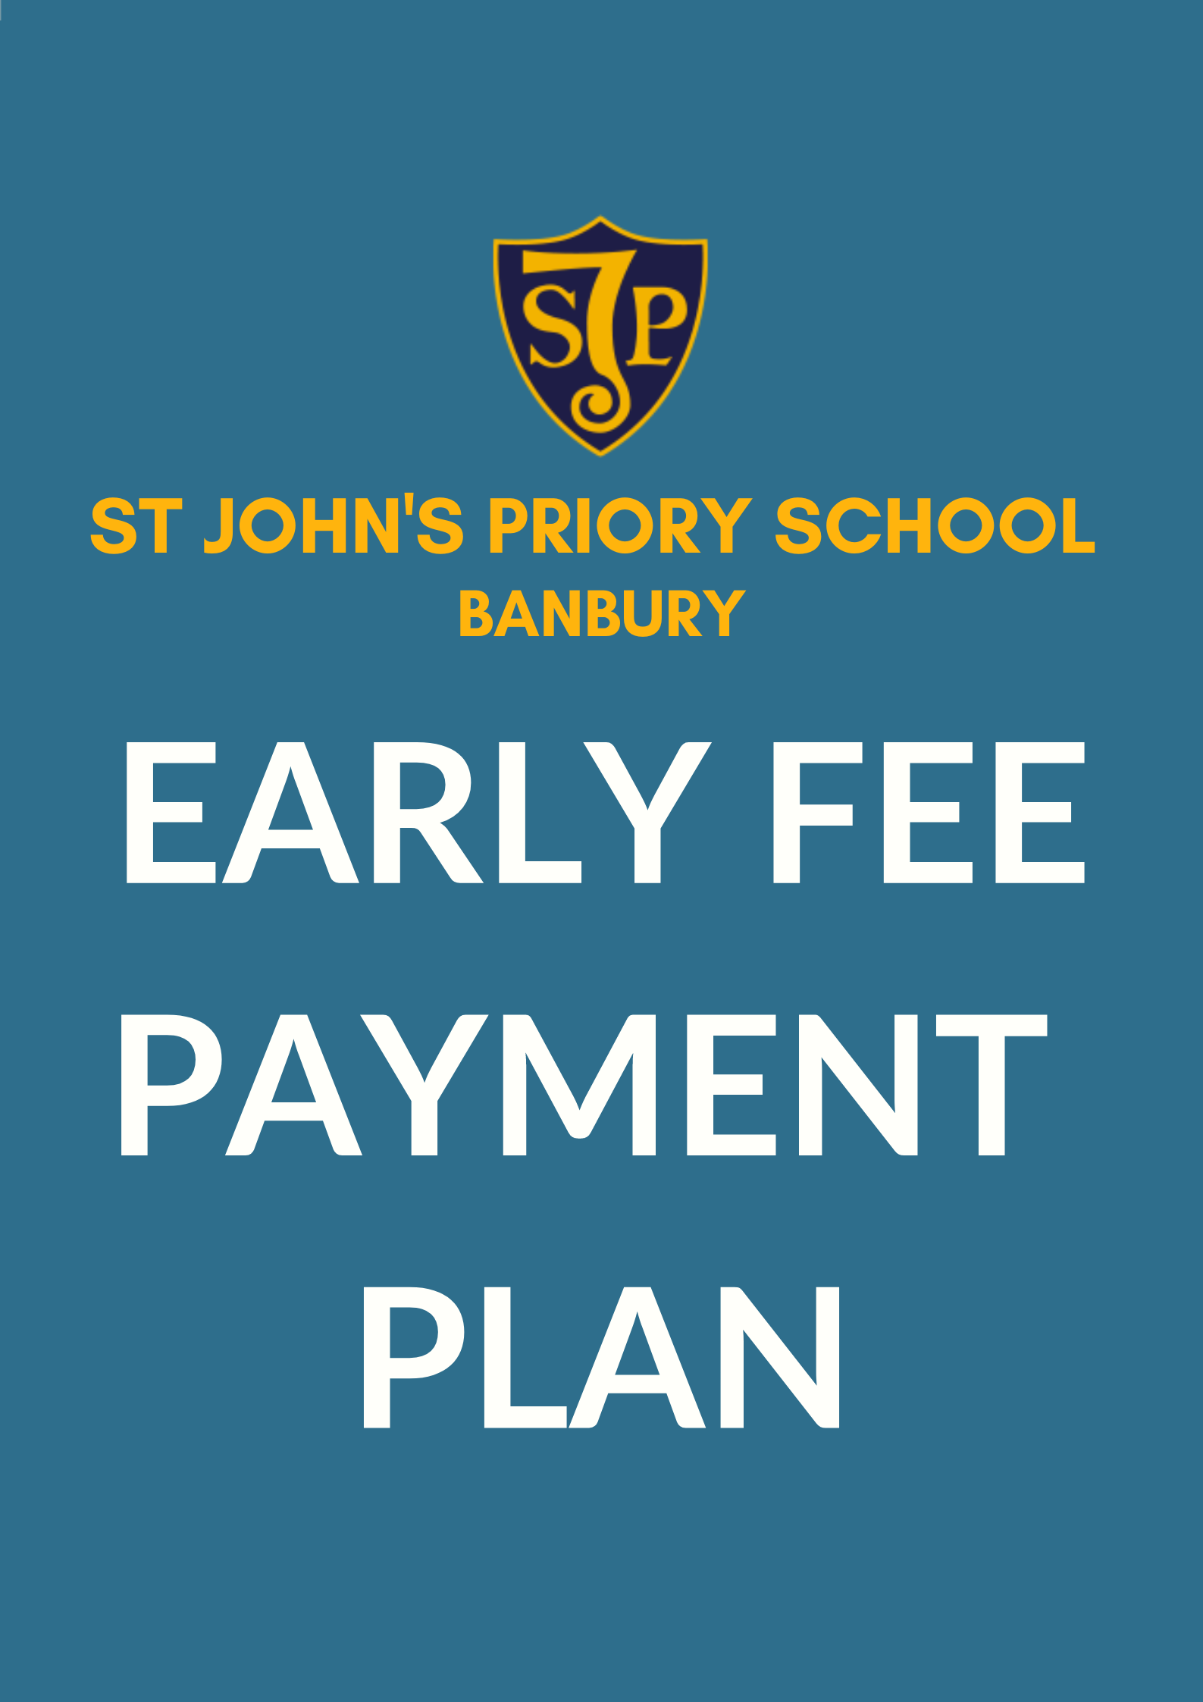

St John’s Road, Banbury, Oxfordshire OX16 5HX
Tel: 01295 259607
sbm@stjohnspriory.co.uk

To School Business Manager, St John’s Priory School

Name of Applicant ………………………………………………………………………………....

Name of Parent (s) …………………………………………………………………………………..

Name of Pupil (s) …………………………………………………………………………………..

- I would like to know how much I would need to deposit to cover the expected cost of …………… years of my child(ren)’s education.

or

- I would like to know how much I would need to deposit to cover the expected cost of the rest of my child(ren)‘s education at St John’s Priory School.

Signed …………………………………………………………………………………………………………..

*******************************************************************

Important Note
St John’s Priory School is not registered to give advice on investment and no information contained in the document should be construed as investment advice. It is recommended you consult an independent financial advisor.

St John’s Road, Banbury, Oxfordshire OX16 5HX
Tel: 01295 259607
sbm@stjohnspriory.co.uk

What is the Fee Early Payment Plan?
Depositing a lump sum can bring considerable savings in paying school fees. St John’s Priory School is pleased to offer a most attractive discounted rate through our Fee Early Payment Plan.

It provides a means whereby the cost of education can be reduced by paying a lump-sum into the Fee Early Payment Plan.

How does it work?
At any time after you have been offered a place for your child, you can make a lumpsum payment for advanced fees to the school and received a 5% discount on the fees.
Those wishing to pay for more than one year in advance will receive a quotation based on an assumed annual fee increase of 3%. Actual fee increases could be more or less than this. Extras are not included in this Plan and are payable each term as incurred.

Payment must be received no later than 5th August.
If your child leaves the school earlier than planned, to take up a place at another private school, no refund will be given. If your child leaves the school for any other reason, each case will be dealt with by the proprietors. Refunds may be issued at the proprietor’s discretion.

St John’s Road, Banbury, Oxfordshire OX16 5HX
Tel: 01295 259607
sbm@stjohnspriory.co.uk

How could this benefit me?
The Fee Early Payment Plan can be attractive in a number of ways depending on personal circumstances:

- Early payment enables you to secure a reduction on fees, thereby assisting you to budget available funds more effectively with the security that future educational costs have been set aside;
- Grandparents may wish to make a lump sum gift to provide assistance with school fees;
- The Fee Early Payment Plan is flexible and can be adapted to each individual ranging from one year to the whole period of schooling.
Individually tailored quotations are available on request from the Bursar and are valid for one month from the date of issue. We will acknowledge receipt of payment, in writing, as soon as it is cleared through the bank and will confirm that the Plan is in force.

Each term a statement will be produced by the Bursar demonstrating the financial position and on-going balance of the Plan.

If you would like a quotation, please complete the form overleaf and return to:
School Business Manager
St John’s Priory School
St John’s Road
Banbury
Oxon
OX16 5HX
E-mail: sbm@stjohnspriory.co.uk
Telephone: 01295 259607

